# JAVA编程进阶上机报告



**学 院 智能与计算学部**

**专 业 软件工程**

**班 级 1**

**学 号 3018216031**

**姓 名 白文杰**

1. **实验要求**
2. **需求描述：**

某计算机组装公司主要销售各类组装计算机，计算机一般由CPU、内存、主板、硬盘等组件构成。具体组件信息如下：

|  |  |  |
| --- | --- | --- |
| 组件名 | 组件品牌 | 组件属性 |
| CPU | Intel、AMD | Name，coreNum，price |
| 内存 | Samsung, Kingston | Name, volume, price |
| 硬盘 | Seagate, WestDigitals | Name, volume, price |
| 主板 | Asus、Gigabyte | Name，speed, price |

每个组件都有自己的工作方式，简单起见，每个组件的工作内容为打印“组件名+work”。

1. **实现功能：**

具体要求：

1. 针对每个组件的每个品牌，设计一个类，并画成整体的类图
2. 设计计算机类（Computer.java），由上述四类组件组装而成，包括计算机的名称、计算机的描述（包括各个组件名）以及总价格等
3. 设计计算机销售主类（ComputerStore.java），包括3个由不同组件组装在一起的计算机实例，可实现计算机商品一览表，可展示每台计算机的描述、价格、工作等。
4. 设计时基于抽象类和接口，要尽可能的实现高内聚、低耦合。

类图：

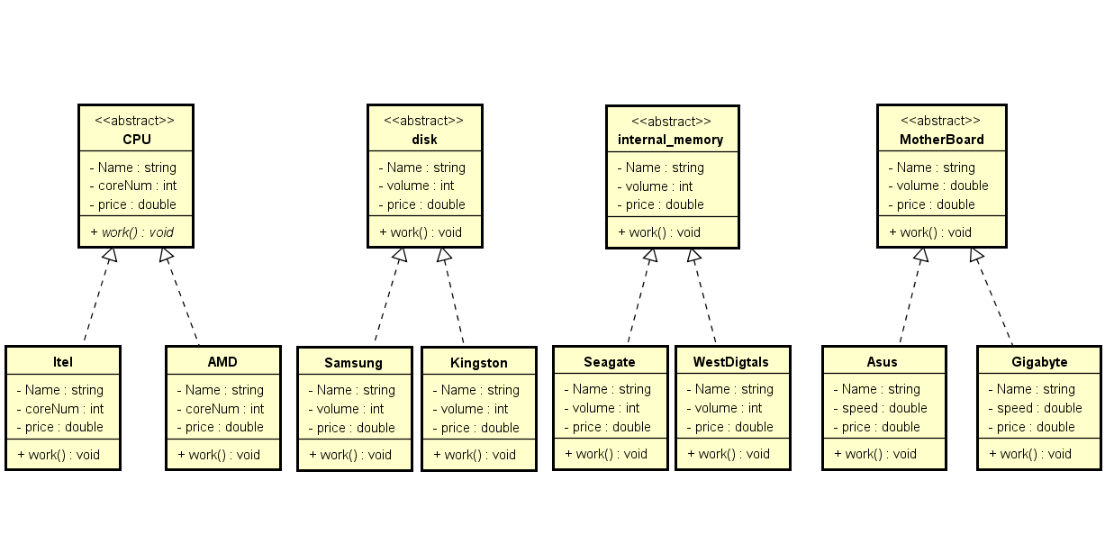

1. **源代码**

**1.**

**package** computer;

**public** **abstract** **class** CPU {

**public** String Name;

**public** **int** coreNum;

**public** **double** price;

**public** CPU(String Name, **int** coreNum, **double** price) {

**this**.Name = Name;

**this**.coreNum = coreNum;

**this**.price = price;

}

**public** **abstract** **void** work();

}

**2.**

**package** computer;

**public** **class** AMD **extends** CPU{

**public** String Name;

**public** **int** coreNum;

**public** **double** price;

**public** AMD(String Name, **int** coreNum, **double** price) {

**super**(Name, coreNum, price);

// **TODO** Auto-generated constructor stub

}

**public** **void** work(){

System.***out***.println("AMD CPU work");

}

}

**3.**

**package** computer;

**public** **class** Intel **extends** CPU {

**public** String Name;

**public** **int** coreNum;

**public** **double** price;

**public** Intel(String Name, **int** coreNum, **double** price) {

**super**(Name, coreNum, price);

// **TODO** Auto-generated constructor stub

}

**public** **void** work() {

System.***out***.println("Intel CPU work");

}

}

**4.**

**package** computer;

**public** **abstract** **class** internal_memory {

**public** String Name;

**public** **int** volume;

**public** **double** price;

**public** internal_memory(String Name, **int** volume, **double** price) {

**this**.Name = Name;

**this**.volume = volume;

**this**.price = price;

}

**public** **abstract** **void** work();

}

**5.**

**package** computer;

**public** **class** Samsung **extends** internal_memory {

**public** Samsung(String Name, **int** volume, **double** price) {

**super**(Name, volume, price);

// **TODO** Auto-generated constructor stub

}

**public** String Name = "Samsung";

**public** **int** volume = 128;

**public** **double** price = 200;

**public** **void** work()

{

System.***out***.println("Samsung Samsung internal_memory work");

}

}

**6.**

**package** computer;

**public** **class** Kingston **extends** internal_memory {

**public** Kingston(String Name, **int** volume, **double** price) {

**super**(Name, volume, price);

// **TODO** Auto-generated constructor stub

}

**public** String Name = "Kingston";

**public** **int** volume = 256;

**public** **double** price = 900;

**public** **void** work()

{

System.***out***.println("Kingston internal_memory work");

}

}

**7.**

**package** computer;

**public** **abstract** **class** disk {

**public** String Name;

**public** **int** volume;

**public** **double** price;

**public** disk(String Name, **int** volume, **double** price) {

**this**.Name = Name;

**this**.volume = volume;

**this**.price = price;

}

**public** **abstract** **void** work();

}

**8.**

**package** computer;

**public** **class** Seagate **extends** disk {

**public** String Name = "Seagate";

**public** **int** volume = 4;

**public** **double** price = 700;

**public** Seagate(String Name, **int** volume, **double** price) {

**super**(Name, volume, price);

// **TODO** Auto-generated constructor stub

}

**public** **void** work() {

System.***out***.println("Seagate disk work");

}

}

**9.**

**package** computer;

**public** **class** WestDigitals **extends** disk {

**public** String Name = "WestDigitals";

**public** **int** volume = 4;

**public** **double** price = 700;

**public** WestDigitals(String Name, **int** volume, **double** price) {

**super**(Name, volume, price);

// **TODO** Auto-generated constructor stub

}

**public** **void** work() {

System.***out***.println("WestDigitals disk work");

}

}

**10.**

**package** computer;

**public** **abstract** **class** mainboard {

**public** String Name;

**public** **double** speed; //单位MHZ;

**public** **double** price;

**public** mainboard(String Name, **double** speed, **double** price) {

**this**.Name = Name;

**this**.speed = speed;

**this**.price = price;

}

**public** **abstract** **void** work();

}

**11.**

**package** computer;

**public** **class** Asus **extends** mainboard{

**public** String Name = "Asus";

**public** **double** speed = 4000; //单位MHZ;

**public** **double** price = 500;

**public** Asus(String Name, **double** speed, **double** price) {

**super**(Name, speed, price);

// **TODO** Auto-generated constructor stub

}

**public** **void** work() {

System.***out***.println("mainboard work");

}

}

**12.**

**package** computer;

**public** **class** Gigabyte **extends** mainboard{

**public** String Name = "Gigabyte";

**public** **double** speed = 3000; //单位MHZ;

**public** **double** price = 400;

**public** Gigabyte(String Name, **double** speed, **double** price) {

**super**(Name, speed, price);

// **TODO** Auto-generated constructor stub

}

**public** **void** work() {

System.***out***.println("Gigabyte mainboard work");

}

}

**13**

**package** computer;

**public** **class** computer {

**public** String computerName;

**public** **double** totalPrice; //总价格

**private** CPU CPU; //computer 含有 CPU

**private** internal_memory InternalMemory; //computer 含有内存

**private** disk Disk; //computer 含有 硬盘

**private** mainboard mainboard;// computer 含有 主板

**public** computer(String computerName, CPU CPU, internal_memory InternalMemory, disk Disk, mainboard mainboard) {

**this**.computerName = computerName;

**this**.CPU = CPU;

**this**.InternalMemory = InternalMemory;

**this**.Disk = Disk;

**this**.mainboard = mainboard;

}

**public** **void** discribe() {

System.***out***.println("The name of this computer is " + computerName);

System.***out***.println("The CPU is " + CPU.Name + ", internal memory is "

+ InternalMemory.Name + ", disk is " + Disk.Name + ", mainboard is " + mainboard.Name);

totalPrice = CPU.price + InternalMemory.price + Disk.price + mainboard.price;

System.***out***.println("The total price of this computer is " + totalPrice);

}//计算机的描述

**public** **void** work() {

CPU.work();

InternalMemory.work();

Disk.work();

mainboard.work();

}

}

**14.**

**package** computer;

**public** **class** ComputerStore {

**public** **static** **void** main(String[] args) {

// **TODO** Auto-generated method stub

CPU cpu1 = **new** Intel("Intel",4,500);

CPU cpu2 = **new** AMD("AMD", 4, 400);

internal_memory i1 = **new** Samsung("Samsung",8,400);

internal_memory i2 = **new** Kingston("Kingston", 16, 800);

disk disk1 = **new** Seagate("Seafate",128,350);

disk disk2 = **new** WestDigitals("WestDigitals",256,590);

mainboard m1 = **new** Asus("Asus",3000,700);

mainboard m2 = **new** Gigabyte("Gigabyte",4000,900);

System.***out***.println("---------The first computer----------");

computer computer01 = **new** computer("A01", cpu1, i1, disk1, m1); //计算机实例A01 Intel,Samsung ,Seafate ,Asus组成

computer01.discribe();

computer01.work();

System.***out***.println("---------The second computer----------");

computer computer02 = **new** computer("B02", cpu2, i2, disk1, m1); //计算机实例B02 AMD,Kingston ,Seafate ,Asus组成

computer02.discribe();

computer02.work();

System.***out***.println("---------The third computer----------");

computer computer03 = **new** computer("C03", cpu2, i2, disk1, m1); //计算机实例C03 Intel,Kingston ,Seafate ,Gigabyte组成

computer03.discribe();

computer03.work();

}

}

1. **实验结果**

**运行结果如下**

